# TECH1015 Multimedia 1

# Coursework 2

Proposal

## Thom Corah (P2555555)

## Outline

This website will be about the anime “Jujutsu Kaisen”. It will have four.

pages:

1. Homepage
   * Welcomes visitors with a brief overview of the site
   * News- Latest news and info on show.
   * Meme of the day- daily photo of Jujutsu Kaisen meme
2. Jujutsu Kaisen real life locations
   * A map of Japan Showing all the real-life locations of Jujutsu Kaisen.
   * Will show real life locations of the show with the adapted anime version next to it.
3. Contact us
   * A simple page with contact details for

## Who is this for?

This website is for the fans of the show Jujutsu Kaisen. This website will provide details of Jujutsu Kaisen and keep fans updated on latest news surrounding the show, it will also give fans real life information on the show. The website will be simple enough for audiences to navigate confidently and so that users who are not particularly web-savvy will still be able to use it effectively.

## Initial Designs

**Home Page**

The menu section will have a link to each of its pages.

Menu, Home, Real life Locations, Contact us

Real Life Locations

Everything you need to know about JUJUTSUS KAISEN

Map

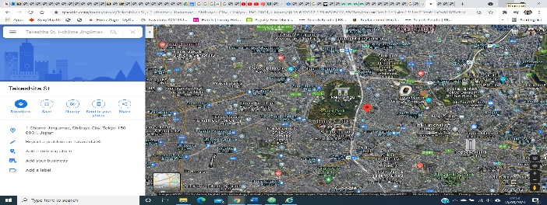

Meme of the Day

(Picture of Meme)

Takeshita Street

IMAGE amime

Takeshita Street

IMAGE

Latest News

Harajuku Station

IMAGE

anime

Harajuku Station

IMAGE

**Fishing Spots Page**

Sendai city

IMAGE

anime

Sendai city

IMAGE



Contact Us

**Contact Page**

The contact page will be a simple page includes an email form for getting in touch with.